**UML Class Diagram:**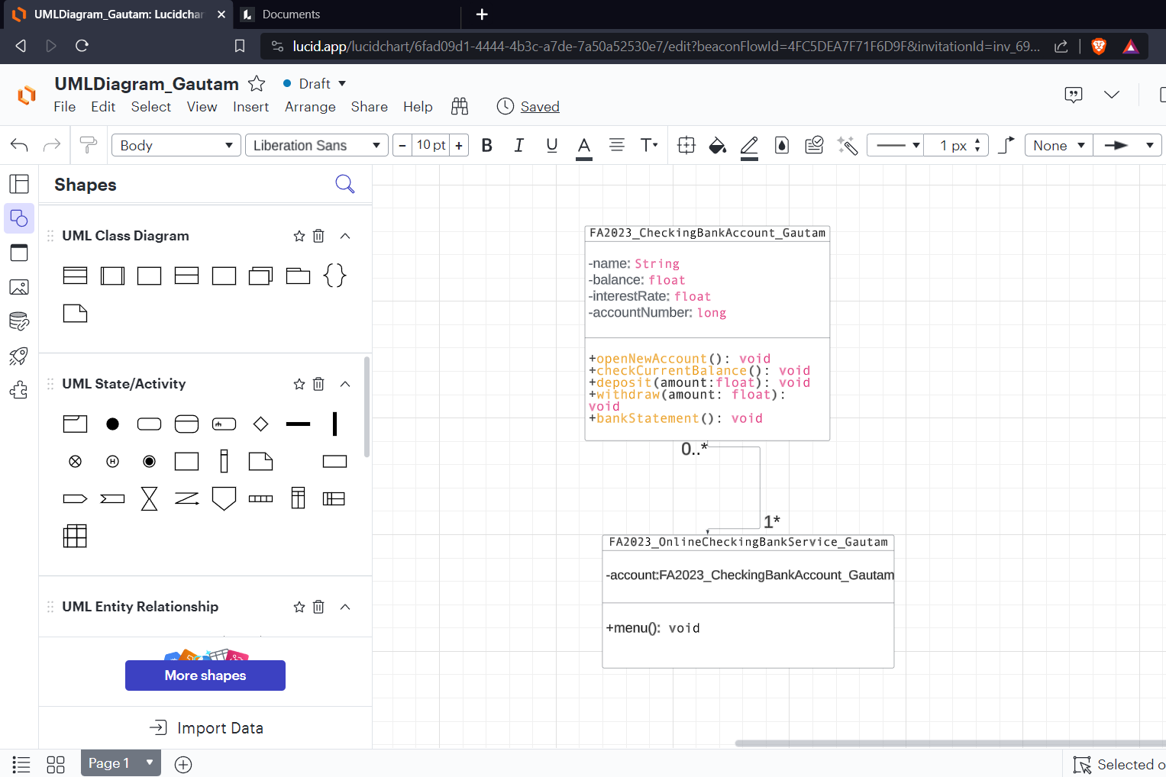

**PseudoCode:  
FA2023_OnlineCheckingBankService_Gautam.java(Driver Class)**

**# Create a data type class for a CheckingBankAccount**

**Class CheckingBankAccount:**

**- accountNumber (String)**

**- accountName (String)**

**- balance (float)**

**- interestRate (float)**

**+ CheckingBankAccount()**

**+ CheckingBankAccount(accountNumber: String, accountName: String, balance: float, interestRate: float)**

**+ openNewAccount(accountName: String, balance: float, interestRate: float)**

**+ checkCurrentBalance()**

**+ checkInterestRate()**

**+ deposit(amount: float)**

**+ withdraw(amount: float)**

**+ bankStatement()**

**# Create an instance of CheckingBankAccount**

**account = CheckingBankAccount()**

**# Display the main menu**

**Display "ONLINE BANK – DIPESH GAUTAM"**

**Display "1. Open New Account"**

**Display "2. Check Current Balance"**

**Display "3. Check Interest Rate"**

**Display "4. Deposit"**

**Display "5. Withdraw"**

**Display "6. Bank Statement"**

**Display "0. Exit"**

**# Repeat until the user selects 0 to exit**

**Repeat:**

**Read userChoice**

**Switch userChoice:**

**Case 1:**

**account.openNewAccount(accountName, balance, interestRate)**

**Case 2:**

**account.checkCurrentBalance()**

**Case 3:**

**account.checkInterestRate()**

**Case 4:**

**account.deposit(amount)**

**Case 5:**

**account.withdraw(amount)**

**Case 6:**

**account.bankStatement()**

**Case 0:**

**Display "Exiting the program."**

**Default:**

**Display "Invalid choice. Please choose again."**

**PseudoCode for the Datatype Class  
FA2023_CheckingBankAccount_Gautam.java(DataType Class)**

**Class FA2023_CheckingBankAccount_Gautam**

**Properties:**

**- name (String)**

**- balance (float)**

**- interestRate (float)**

**Methods:**

**- Constructor FA2023_CheckingBankAccount_Gautam()**

**Initialize name = ""**

**Initialize balance = 0.0**

**Initialize interestRate = 0.0**

**- Method openNewAccount(name: String, balance: float, interestRate: float)**

**Set this.name = name**

**Set this.balance = balance**

**Set this.interestRate = interestRate**

**- Method checkCurrentBalance()**

**Output "CURRENT ACCOUNT"**

**Output "Account Number: [generate account number]"**

**Output "Account Name: " + this.name**

**Output "Balance: " + this.balance**

**- Method checkInterestRate()**

**Output "INTEREST RATE"**

**Output "Account Number: [generate account number]"**

**Output "Account Name: " + this.name**

**Output "Balance: " + this.balance**

**Output "Interest Rate: " + this.interestRate + "%"**

**- Method deposit(amount: float)**

**Set this.balance = this.balance + amount**

**Output "DEPOSIT"**

**Output "Account Number: [generate account number]"**

**Output "Account Name: " + this.name**

**Output "Balance: " + this.balance**

**Output "Deposit: " + amount**

**Output "New Balance: " + this.balance**

**- Method withdraw(amount: float)**

**If (this.balance - amount >= 100.0)**

**Set this.balance = this.balance - amount**

**Output "WITHDRAW"**

**Output "Account Number: [generate account number]"**

**Output "Account Name: " + this.name**

**Output "Balance: " + this.balance**

**Output "Withdraw: " + amount**

**Output "New Balance: " + this.balance**

**Else**

**Output "WITHDRAW"**

**Output "Account Number: [generate account number]"**

**Output "Account Name: " + this.name**

**Output "Balance: " + this.balance**

**Output "Withdraw: " + amount + " - denied"**

**Output "New Balance: " + this.balance**

**- Method bankStatement()**

**interestAmount = this.balance * (this.interestRate / 100)**

**Set this.balance = this.balance + interestAmount**

**currentDate = [generate current date]**

**Output "BANK STATEMENT"**

**Output "Statement Date: " + currentDate**

**Output "Account Number: [generate account number]"**

**Output "Account Name: " + this.name**

**Output "Balance: " + this.balance**

**Output "Interest Rate: " + this.interestRate + "%"**

**Output "Interest Amount: " + interestAmount**

**Output "New Balance: " + this.balance**

**<<<<<<<<<<<<<<<<<<<<<<<Output Pictures:>>>>>>>>>>>>>>>>>>>>>>>>>>>>**